Aarya Arban
T11 – 05
Assignment No. 5
Aim: Implementation of Statistical Hypothesis Correlation Test
- What is correlation and covariance?
Both correlation and covariance measure the relationship between two variables, but they have different properties and interpretations.
1. Covariance
- Definition: Covariance measures the direction of the relationship between two variables. It tells us whether the variables move together (positive covariance) or in opposite directions (negative covariance).
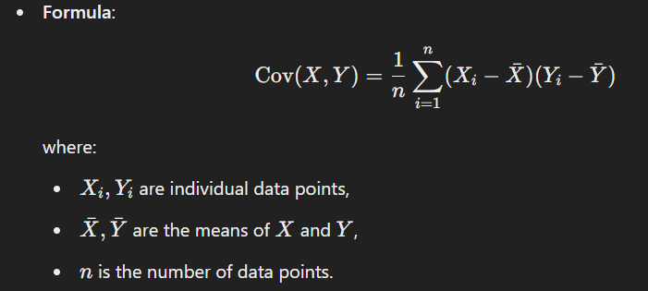
- Interpretation:
  - Positive covariance: Both variables increase or decrease together.
  - Negative covariance: When one variable increases, the other decreases.
  - Zero covariance: No linear relationship.
- Limitation: Covariance is scale-dependent, meaning it depends on the units of the variables.

2. Correlation
- Definition: Correlation standardizes covariance, making it unit-free. It measures both the strength and direction of a linear relationship between two variables.
- Formula:
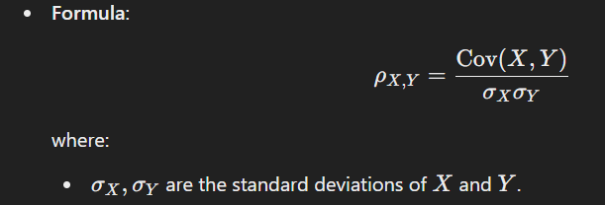
- Interpretation:
  - Ranges from -1 to +1:
    - +1 → Perfect positive correlation.
    - 0 → No correlation.
    - −1- → Perfect negative correlation.
- Advantages: Unlike covariance, correlation is unit-independent, so it allows for comparisons across different datasets.
- What is the role of correlation in data science?
Role of Correlation in Data Science
Correlation plays a crucial role in data science, as it helps in understanding relationships between variables, improving model performance, and making data-driven decisions. Below are some key roles of correlation in data science:
1. Feature Selection & Dimensionality Reduction
- Correlation helps identify highly related features, allowing for the removal of redundant variables.
- Example: If two features are highly correlated, one can be dropped to avoid multicollinearity, improving model efficiency.
2. Identifying Relationships in Data
- Correlation helps determine whether two variables move together (positive correlation) or in opposite directions (negative correlation).
- Example: In sales analysis, a strong positive correlation between advertising spends and revenue suggests a relationship between the two.
3. Improving Machine Learning Models
- Correlation helps in selecting important predictors and removing irrelevant ones, leading to better model accuracy.
- In regression models, highly correlated independent variables can cause multicollinearity, which affects model interpretability.
4. Data Preprocessing & Cleaning
- Correlation helps detect errors or anomalies in data.
- Example: If age and years of experience have a negative correlation, it might indicate a data entry issue.
5. Time Series & Forecasting
- Correlation is used to measure relationships between past and future values in time series forecasting.
- Example: Stock prices of different companies may be correlated, influencing investment decisions.
6. Market Basket Analysis & Recommendation Systems
- In e-commerce and marketing, correlation is used to find associations between products.
- Example: If customers who buy laptops also frequently buy laptop bags, this correlation can be used for cross-selling strategies.
7. Risk Management & Finance
- In finance, correlation helps in portfolio diversification by identifying assets that move independently.
- Example: Stocks with low or negative correlation reduce overall risk in a portfolio.
8. Medical & Scientific Research
- Correlation helps analyse relationships between variables in experiments.
- Example: Finding correlations between smoking and lung disease in medical studies.

1. Calculate covariance (Age, Strength) and correlation (Age, strength) for following data using
- Pearson’s Correlation coefficient method
- Spearman’s rank correlation method (use scipy.stats.pearsonr and scipy.stats.spearmanr function)
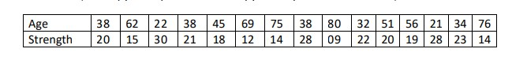
Program:
import numpy as np
from scipy.stats import pearsonr, spearmanr age=np.array([38,62,22, 38, 45, 69, 75, 38, 80, 32, 51, 56, 21, 34, 76]) strength = np.array([20, 15, 30, 21, 18, 12, 14, 28, 9, 22, 20, 19, 28, 23, 14]) covariance=np.cov(age,strength)[0,1]
print(f"Covariance (Age, Strength): {covariance:.2f}") pearson_corr, _ = pearsonr(age, strength)
print(f"Pearson's Correlation Coefficient: {pearson_corr:.4f}")
spearman_corr, _ = spearmanr(age, strength)
print(f"Spearman's Rank Correlation Coefficient: {spearman_corr:.4f}")

Output:
Covariance (Age, Strength): -111.00
Pearson's Correlation Coefficient: -0.9229
Spearman's Rank Correlation Coefficient: -0.9362
Conclusion:
The negative covariance (-111.00) and strong negative Pearson (-0.9229) and Spearman (-0.9362) correlation coefficients indicate a strong inverse relationship between age and strength. As age increases, strength tends to decrease significantly. The high Spearman value suggests this trend holds even in ranked data.

2. Load the california_housing dataset from scikitlearn. Find the correlation between each of the features using pearson’s method and spearman’s method. Draw the heatmap for both cases. Identify if any redundant features are there and which independent features are highly correlated with dependent feature. Use following lines of code to import the dataset from sklearn and then create the dataframe from it: from sklearn.datasets import fetch_california_housing housing = fetch_california_housing() Program:
import pandas as pd import numpy as np import seaborn as sns import matplotlib.pyplot as plt
from sklearn.datasets import fetch_california_housing

housing = fetch_california_housing()

df = pd.DataFrame(housing.data, columns=housing.feature_names)

df['MedHouseVal'] = housing.target

pearson_corr = df.corr(method='pearson')

spearman_corr = df.corr(method='spearman')

plt.figure(figsize=(14, 7))

plt.subplot(1, 2, 1)
sns.heatmap(pearson_corr, annot=True, fmt='.2f', cmap='coolwarm', vmin=-1, vmax=1)
plt.title('Pearson Correlation Heatmap')

plt.subplot(1, 2, 2)
sns.heatmap(spearman_corr, annot=True, fmt='.2f', cmap='coolwarm', vmin=-1, vmax=1)
plt.title('Spearman Correlation Heatmap')

plt.tight_layout() plt.show() threshold = 0.9 redundant_features = [] for column in pearson_corr.columns: high_corr_features = pearson_corr.index[pearson_corr[column] > threshold].tolist() high_corr_features.remove(column) # Remove the feature itself from the list if high_corr_features:
redundant_features.append((column, high_corr_features))

print("Redundant features (highly correlated with each other):") for feature, correlated_features in redundant_features:
print(f"{feature} is highly correlated with {', '.join(correlated_features)}")

correlation_with_target = pearson_corr['MedHouseVal'].drop('MedHouseVal') high_corr_with_target = correlation_with_target[abs(correlation_with_target) >
0.5]

print("\nIndependent features highly correlated with the dependent feature
(MedHouseVal):") print(high_corr_with_target) Output:
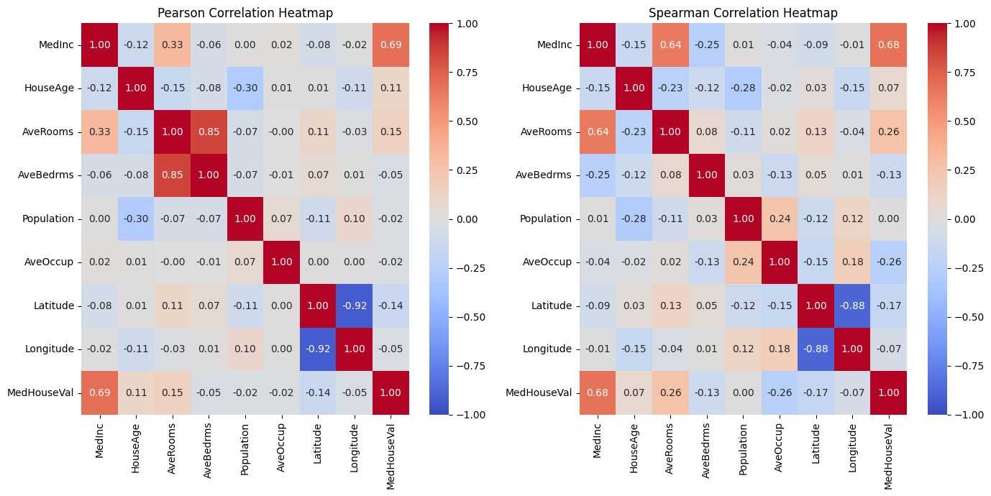

Redundant features (highly correlated with each other):

Independent features highly correlated with the dependent feature (MedHouseVal):
MedInc 0.688075
Name: MedHouseVal, dtype: float64
Conclusion:
The Pearson and Spearman correlation heatmaps reveal key relationships between housing dataset features. Median Income (MedInc) and Median House Value (MedHouseVal) show a strong positive correlation (~0.69 Pearson, ~0.68 Spearman), indicating that higher income areas tend to have higher house values. Latitude and Longitude exhibit a strong negative correlation (~-0.92 Pearson, ~-0.88 Spearman), suggesting a geographical trend in housing values. Spearman's correlation captures more nonlinear relationships, as seen in the stronger correlation between AveRooms and MedHouseVal (0.33 Pearson vs. 0.64 Spearman), highlighting a possible ranking effect

